Nick Chonko

Tim Walsh

SoCalendar: Final Design Report

# Project Description:

The goal of our application is for a user to be able to put scheduled events into a calendar as well as times when they would like to do social activities. The user then can add tasks that need to be completed during daily life and the user’s tasks will be added to the calendar during available time slots. Finally, the social aspect is that the user will be recommended things to do during their social times, such as concerts, restaurant deals, and fitness classes. In addition, the user will be able to add friends and recommend that they participate in activities with them.

# User Interface Specifications:

# Test Plan and Results:

<https://gitlab.com/jebidis93/senior-design-planning/-/blob/master/test-plans.md>

In the backend, our main testing strategy is to make unit tests for almost everything we write. We have installed pytest as our testing framework. The backend uses a test database that is used when tests are run and all artifacts from testing are completely removed between every test.

In the frontend, our plan is to test core UI/UX functionality. This will mean simple front end navigation tests as well as in-def end to end test for getting results from the back end.

# User Manual

<https://gitlab.com/jebidis93/senior-design-planning/-/wikis/home>

# Power Point

<https://gitlab.com/jebidis93/senior-design-planning/-/commit/eb0bc3317f582fead372bf6ab39751cb517642f8>

# Final Expo Poster

<https://gitlab.com/jebidis93/senior-design-planning/-/blob/master/Poster_Final.pdf>

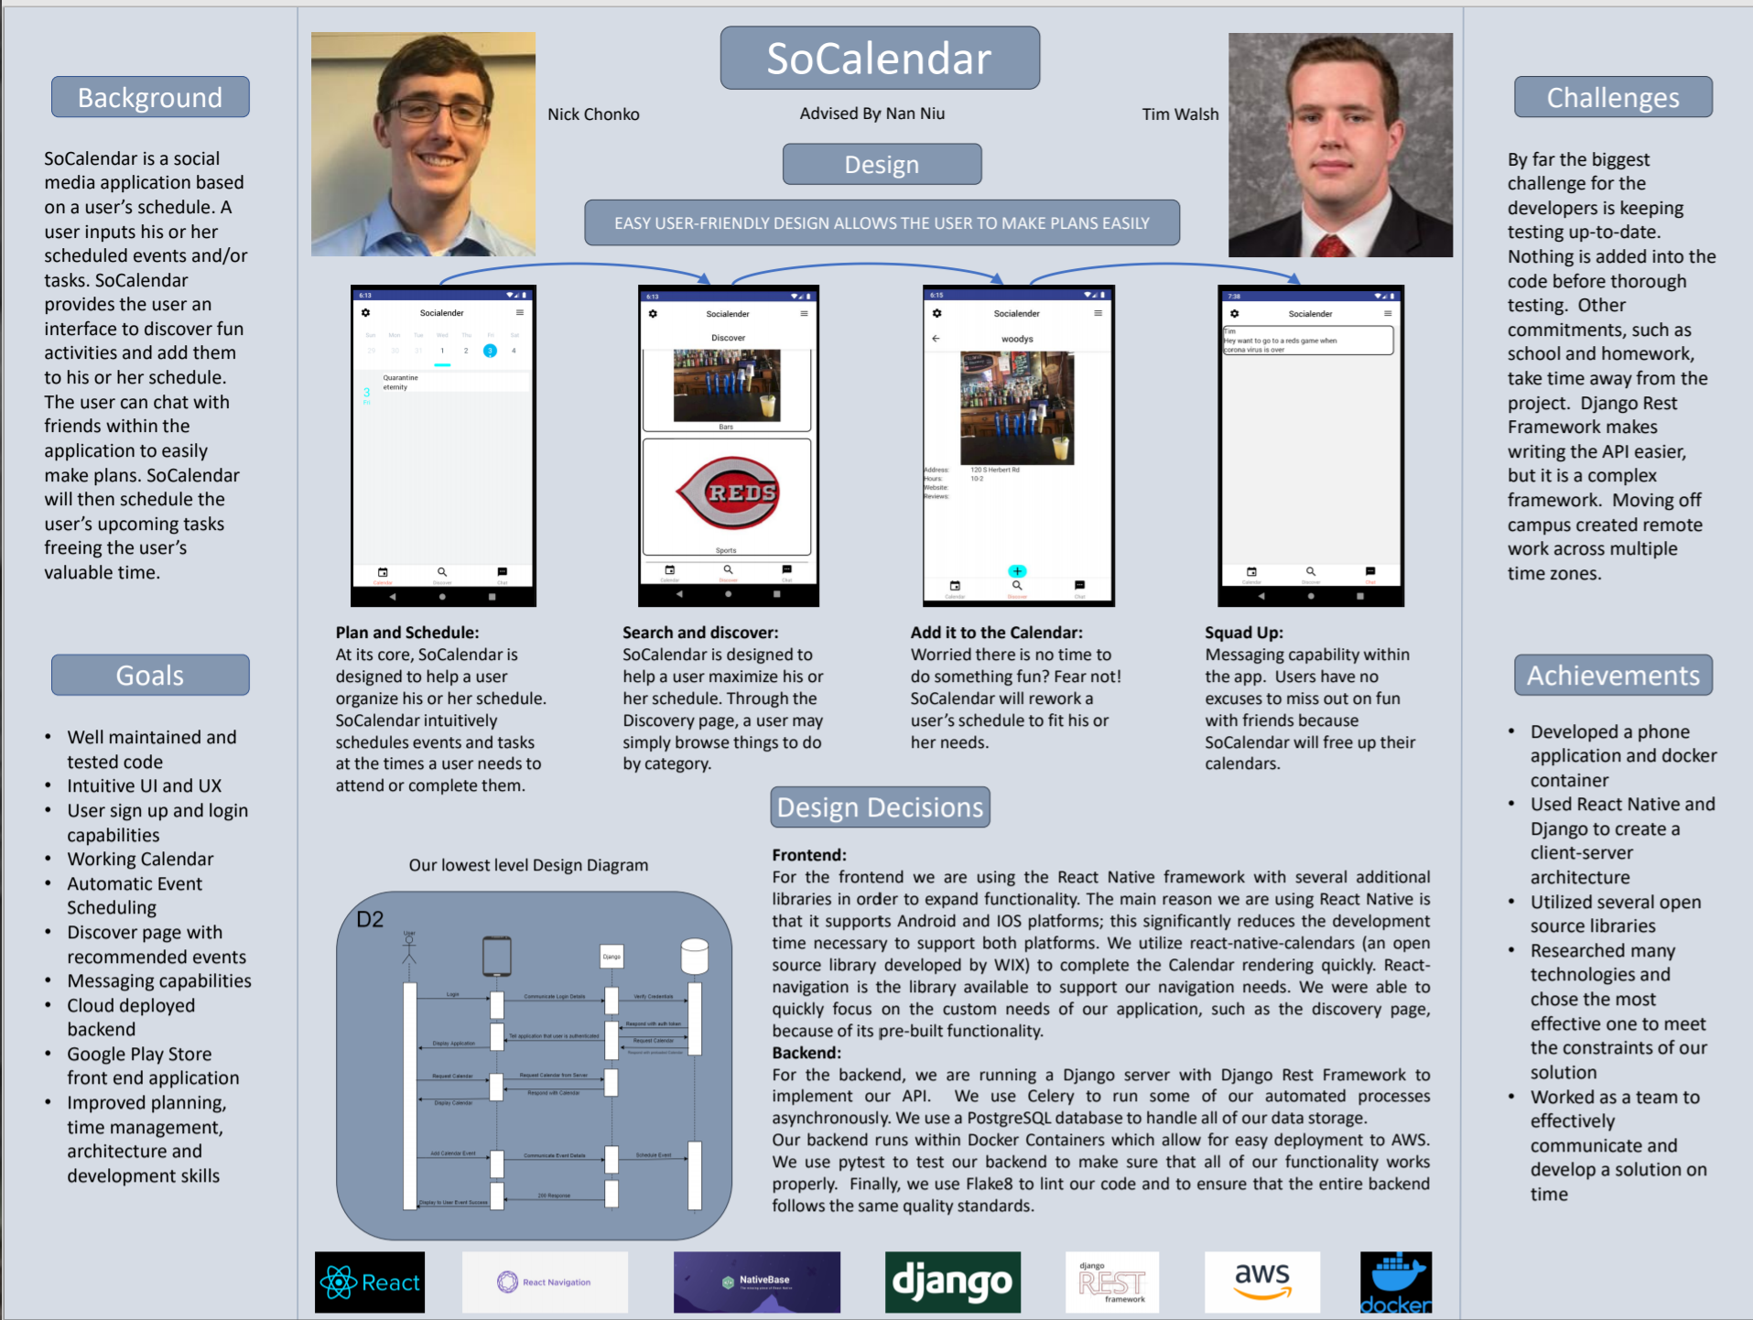

# Assessments

**Nick Initial**

**Nick Final**

**Tim Initial**

For our senior design project, we are making a self-scheduling calendar. This calendar will also include a social media aspect that allows users to easily plan things to do with friends. There are other products out there that help users schedule their lives automatically. However, they do not have the social aspects that our application will. This project will allow our team to expand our knowledge and understanding of many technologies, such as Google Calendar and Reactjs. The project will focus on developing our skills application and cloud development.

Throughout my college experience I have learned a lot that will help me with developing this application. From classes I have learned important concepts from my networking, requirements engineering and python courses. Networking will be applied when we connect the application to the server securely. Requirements engineering has taught me the skills necessary to come up with a proper project plan, which will help us work efficiently. Python will help us develop the back-end server and allow us to easily and securely communicate with our database and Google. There are other things that I have learned from courses like Algorithms and Artificial Intelligence that I am sure will be used, but we have not determined how at this moment.

More importantly then our course work I have learned a lot during my CO-OP experiences. I have developed so many skills from CO-OP that will help with this project and it would be impossible to discuss them all. At Siemens I learned the fundamentals of full stack development and software analytics. The skills I learned at Siemens which will help me develop a good user interface and experience. At DFIN I worked in cloud development and honed my skill in full stack development. The skills I learned at DFIN will help us create and effective and working back end.

Not only is this project something that I believe in, but it is an excellent opportunity to test my skills, challenge myself and learn some new things along the way. Theis projects origins come from an idea that I had 5 or 6 years ago now. I have done a few basic self-scheduling calendars since I had the idea, but I know that we can make a massive improvement to the earlier versions. The addition of the social media aspect to this application is what truly excites me. I genuinely believe that this application could be popular if executed properly. It will be difficult, but I really think that we can make something great.

**Tim Final**

My primary development responsibilities for this project was to develop the front end of a phone application. Other than that Nick and I split the work when it came to documentation and architecting communication between the phone and server. At the beginning of this project my goal was to improve my front-end development skill with React-Native. I had gotten minimal experience throughout my CO-OPs developing front ends, so this was so this was a really intriguing process for me.

I got to plan, layout and design the entire front facing application for this project, to do this I had to consider visual appeal and functional ease. I went through a number of design iterations and was constantly evolving things. I made the mistake of designing screens before laying out navigation, which I learned doing navigation first would have saved me a lot of headaches. I also made the mistake of using some libraries which didn’t provide benefits to me in the long run I then had to cut them out of the code base and rewrite their functionality. Rewriting the functionality served to benefit my skills and the application worked better, however this took a lot of time and lead to me not finishing some features that I wanted.

# Summary of Hours and Justification

**Nick**

**Tim**

|  |  |  |
| --- | --- | --- |
| **Task** | **Description** | **Hours** |
| Render Screens for assignments | This task is for the time spent rendering dummy screens to be used in assignments. This includes highlighting features for the purpose of the assignment | **8** |
| User Manual | For this assignment I had to create a wiki on how the application works | **7** |
| Final Poster | My part in the writing, editing and design | **4** |
| Front End Video | I created a ~10 minute video about the front end for the expo | **1** |
| Other assignments | Assignments that are not listed | **5** |
| Develop Calendar Screens | This task represents developing the looks and functionality for the screens withing the Calendar Tab of the application | **7** |
| Develop Discover Screens | This task represents developing the looks and functionality for the screens withing the Discover Tab of the application | **10** |
| Develop Message Screens | This task represents developing the looks and functionality for the screens withing the Message Tab of the application | **4** |
| Application Navigation | As stated in my final assessment I wish I had done this first, it was hard to do in the first place and even harder to intigrate after the fact | **8** |
| Login/Signup screens | We had a bunch of issues at the end of the project with our authorization protocols and these were quite difficult to get working | **7** |
| Connect To back end | I was unable to install docker for windows on my machine and had several problems getting docker toolbox running, which was necessary to connect the application | **5** |